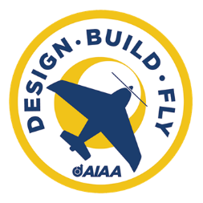

University of Houston – Space City Aeronautics
2025 – 2026 AIAA Design, Build, Fly Proposal
- Executive Summary
This proposal is the best proposal American Institute of Aeronautics and Astronautics has ever seen. I am writing these words to check formatting. Do NOT freak. This proposal is the best proposal American Institute of Aeronautics and Astronautics has ever seen. I am writing these words to check formatting. Do NOT freak. This proposal is the best proposal American Institute of Aeronautics and Astronautics has ever seen. I am writing these words to check formatting. This proposal is the best proposal American Institute of Aeronautics and Astronautics has ever seen. I am writing these words to check formatting. Do NOT freak. This proposal is the best proposal American Institute of Aeronautics and Astronautics has ever seen. I am writing these words to check formatting. Do NOT freak.
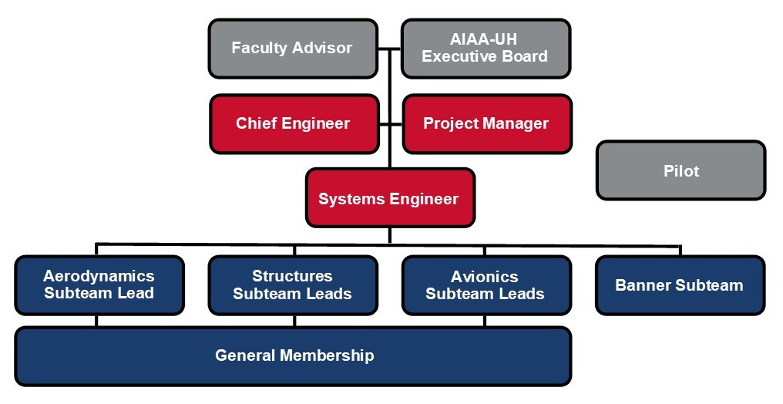
- Management Summary
  - Team Organization
Space City Aeronautics is a competitive student design team within the University of Houston Chapter of the American Institute of Aeronautics and Astronautics. AIAA-UH also acts as the team’s administrative and financial parent organization, assisting with budget management, purchasing, and compliance with university regulations. The team consists of 16 undergraduate students and is advised by Alumni, Faculty, and graduate advisors. The team is led by the Project Manager, Chief Engineer, and Systems Engineer, who oversee project development across logistical, technical, and integration areas, respectively. Space City Aeronautics is organized into three technical sub-teams: Aerodynamics, Structures, and Avionics, each led by one or two experienced members responsible for technical execution, documentation, and mentorship of new members. Sub-team leads meet weekly to report progress, coordinate integration plans, and discuss procurement and testing needs. General team meetings occur twice a week to share updates and carry out design, manufacturing, and testing activities. The fourth sub-team covers the Banner System and is composed of four Mechanical Engineering Capstone members. Detailed roles and associated skills are further described in Table 1.
Figure 1. Team Organizational Structure
Table 1. Sub-team roles and skills
Sub-Teams | Roles | Skill Sets
Aerodynamics | Designs, analyzes, and manufactures wings, empennage, and control surfaces. Performs aerodynamic and stability analysis using computational and experimental methods. | Aerodynamic Analysis (XFLR5), CFD simulation, MATLAB, CAD modeling
Avionics | Determines and applies electrical and signal components in the aircraft. Integrates and tests electronic components, including motor control, sensors, and telemetry. Supports flight testing and data acquisition. | Circuit design, soldering, wiring, CAD modeling
Structures | Designs, analyzes, and manufactures fuselage, landing gear, and other physical aspects of the airframe. Ensures structural integrity and optimizes weight and spatial distribution through analysis and testing. | CAD modeling, structural Finite Element Analysis, CAM, composite materials, fabrication, 3D printing, laser cutting
Banner System | Designs, implements, and tests banner deployment system, ensuring compliance with mission-specific requirements. | CAD modeling, system integration, wind tunnel testing

  - Gantt Chart

  - Budget
- Conceptual Design
  - Analysis of Mission Requirements
We have analyzed the mission requirements. Here is what we found:
  - Sensitivity Analysis
The big beautiful sensitivity analysis plot goes here.
  - Preliminary Design
    - Landing Gear Configuration
In the testing process, there was a natural inclination towards a taildragger configuration, one that the team had prior experience with. After completing the study, however, a tricycle configuration performed the best. This trade study evaluated a tail dragger, tricycle, and quadricycle based on their performance in the following: landing characteristics, banner interference, structural integrity, and ground stability.
    - Empennage and Wing Configuration
For the configuration of the lift surfaces, the team implemented a high-wing, conventional tail. This design allows for the most space for optimization of cargo, passengers, and banner deployment equipment while still offering sufficient structural integrity and aerodynamic stability.
Table 2. Wing and Empennage Decision Matrix
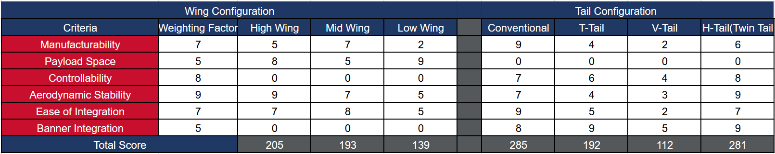
    - Fuselage Configuration
The team chose an integrated fuselage to allow for more passengers and cargo while minimizing the length of the aircraft. While taking into account the parameters for the second mission, the electronic components, and the structural elements of the aircraft, the decision was made to utilize an integrated fuselage design.

X
    - Airfoil and Wing Shape Selection
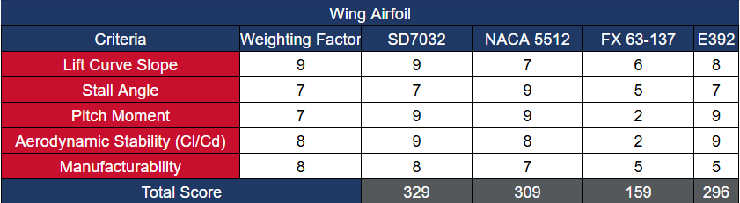
s
Table 3. Airfoil Decision Matrix
After considering the desired take-off weight for M2 and the increased drag after banner deployment in M3, it was determined that it is important for the airfoil to have a Cl/Cd (Coefficient of Lift/Coefficient of Drag) between 12-15, a pitch moment near 0 N*m during non-turbulent flight, a reasonable stall angle, and feasible manufacturability. For these reasons, SD7032 was selected having a Cl/Cd of 13.7, a stall angle of 17 degrees at cruise conditions and stable pitch moment during non-turbulent flight. Additionally, the airfoil is ergonomic due to low camber.

    - Wing Configuration X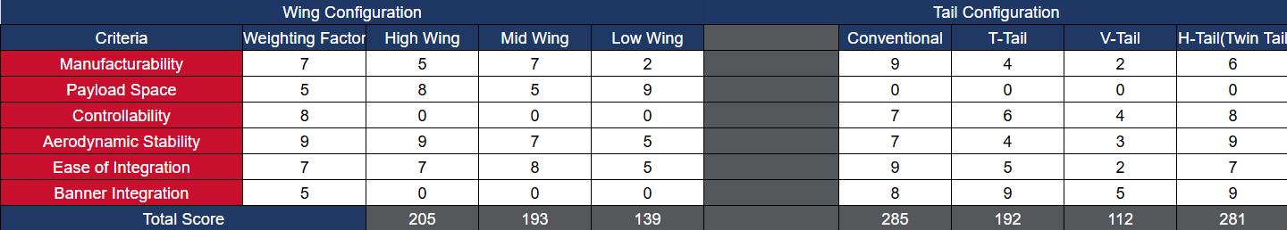

    - Propulsion System
For the Avionics/Propulsion system of the aircraft, the team has selected these components based on price, weight, functionality, and was designed to maximize flight time The Spektrum NX8 DSMX transmitter connects to a Spektrum AR8360T 8 channel receiver through the 2.4GHz radio band. This receiver was chosen due to its compatibility with our current transmitter and the number of control channels. The receiver controls the electronic speed controller and the 7 Daryl branded servos. These servos control the 5 control surfaces on the wings and empennage, as well as the banner release system. The aircraft’s propulsion system will utilize close to the maximum allowed battery capacity of 100Wh. This will be done with a Liperior 4500mAh 22.2V 6s battery rated at 99.9Wh. This battery will power the 370kv SunnySky X5320 Motor with a 20*8 propeller. This motor and propeller as chosen due to its high thrust of 6650gf, reasonable current draw of 61.2 Amps, and the overall efficiency of this motor and propeller combination. The Spektrum Avian 100A ESC was chosen to control the motor due to the current requirement, price, weight, and its programmable capability.
    - Banner Release Mechanism
The banner will be secured directly beneath the fuselage using two straps, as shown in Figure X. To deploy the banner, servo-actuated hooks will rotate upward, releasing the straps and allowing the banner to drop and unfurl naturally under gravity. After completing the final lap, a secondary servo located at the rear of the aircraft equipped with another hook mechanism will release the towing line, detaching the entire banner system from the plane. See figure X.
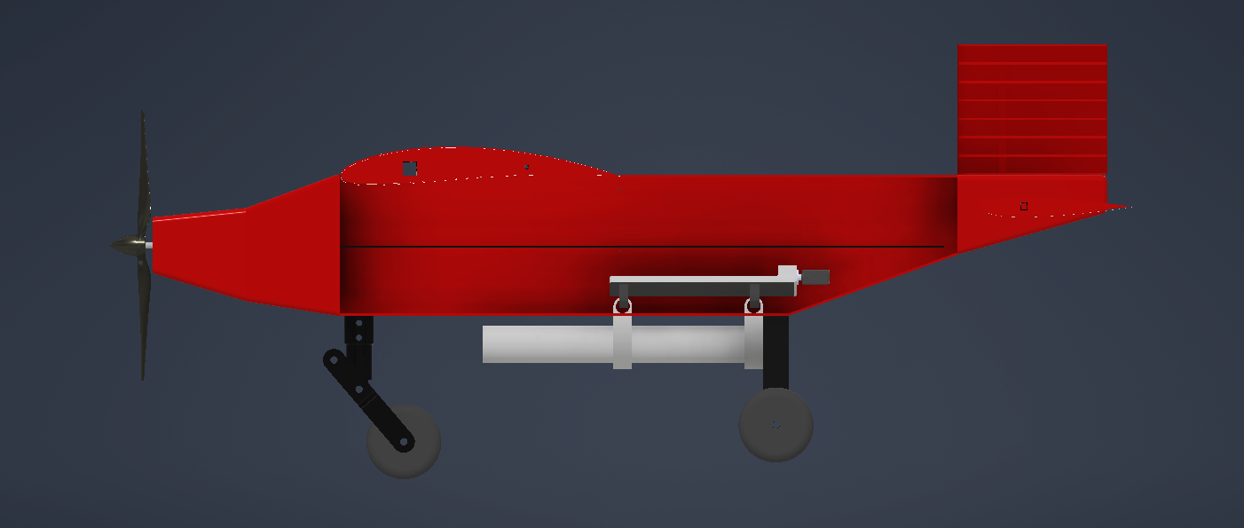

- Manufacturing Plan
  - Manufacturing Overview
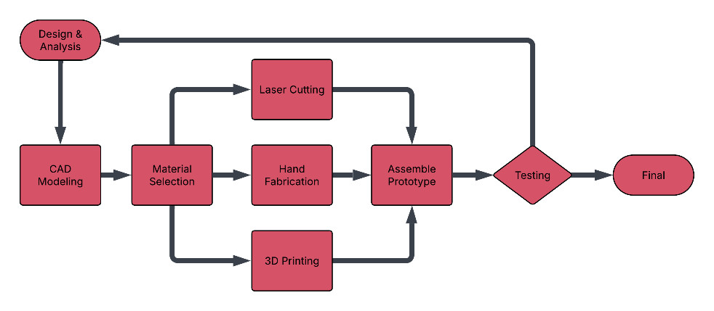
This year, the team aims to develop a high quality prototype and conduct rigorous testing to gather performance data and validate design decisions. The goal of this preliminary development is to use the insights gained from testing to optimize the final competition aircraft. The overall manufacturing process is outlined in Figure X.
Figure 2 - Manufacturing Flow Chart
  - Critical Processes
The primary structure of the fuselage, wings, and empennage will be fabricated using laser-cut ribs made from a combination of basswood and balsa, providing an optimal balance between structural strength and weight efficiency. Once assembled, the airframe will be covered with Monokote to improve aerodynamic smoothness and reduce drag. Components with complex geometries, including the nose cone and landing gear fairings, will be additively manufactured using PETG-CF filament to achieve high strength, dimensional accuracy, and reduced mass. Control surfaces will be constructed from foam, shaped precisely using a hot wire foam cutter to ensure lightweight design and aerodynamic consistency. The passenger mounting mechanism will be fabricated from flexible TPU filament to accommodate variations in passenger (duck) size while maintaining secure attachment. Finally, the banner deployment and release mechanisms will be 3D printed to ensure precision, repeatability, and seamless integration into the overall aircraft design.
- Test Planning
Motor test will be done with a load cell that is fixed, to evaluate different propellers with our chosen motor to find the optimal motor prop combination. An electronic bench test will be done to validate the electronic circuit of the aircraft.

